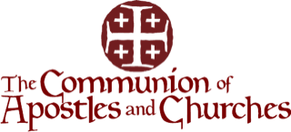
CAC India Apostolic Campaign February Report 2022
Dear Presiding Apostle and General Members of CAC Council,
Greetings in the Mighty name of our High Priest and King Lord Jesus Christ.
We thank God for enabling CAC India to advance the Kingdom of God in South East Asia as well in these times of Pandemic and Persecution. And also very grateful for Apostle George Kouri and Apostle Mike Daub’s and all the members for your prayers and support which is accelerating the work in the sub- continent.
Our Prayer is “Thy Kingdom come. Thy will be done on earth as it is in Heaven”.

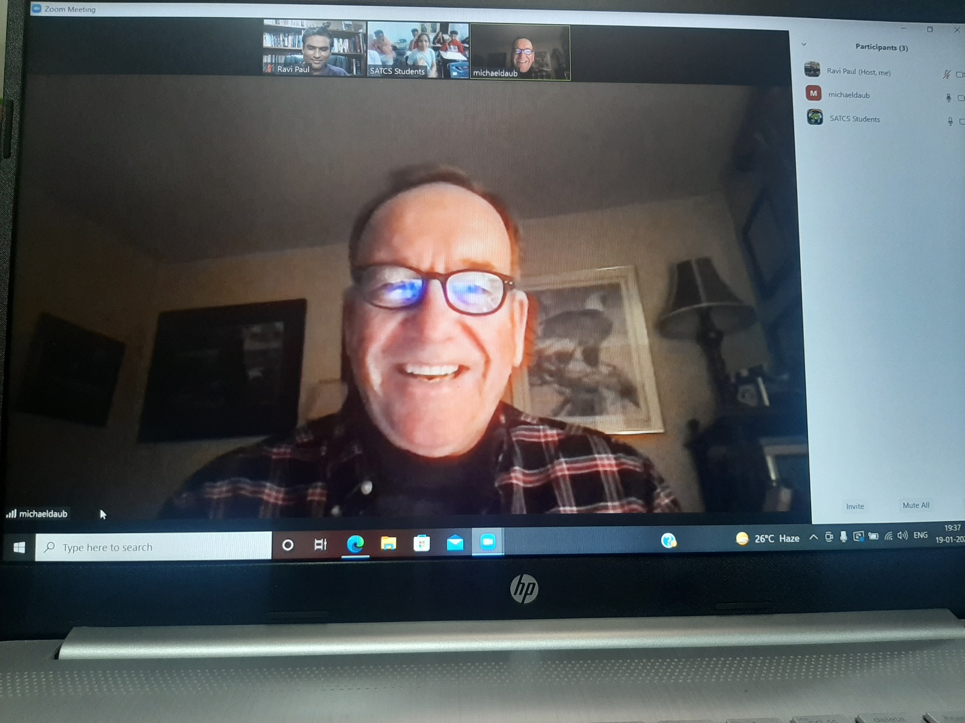
ATS COURSES BEING TAUGHT BY APOSTLE MIKE DAUB TO SEMINARY STUDENTS

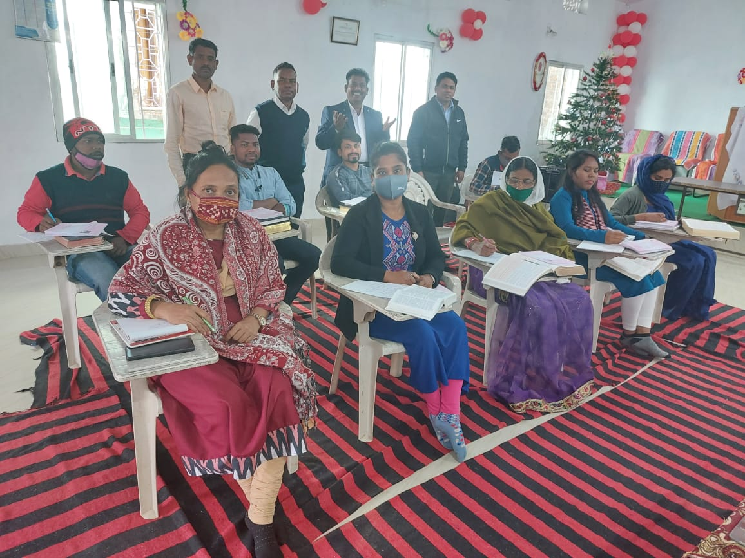
ATS STUDENTS BEING TAUGHT BY DR.SURYA
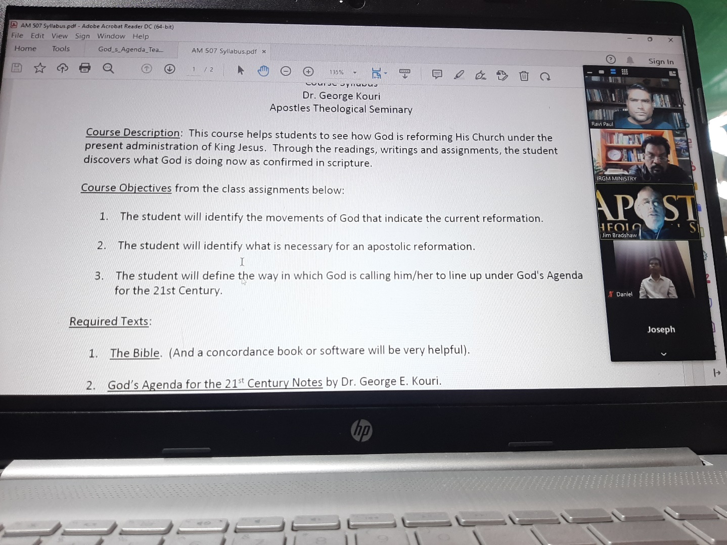
Dr.Bradshaw teaching ATS Curriculum to the Doctoral students from Chennai, India.

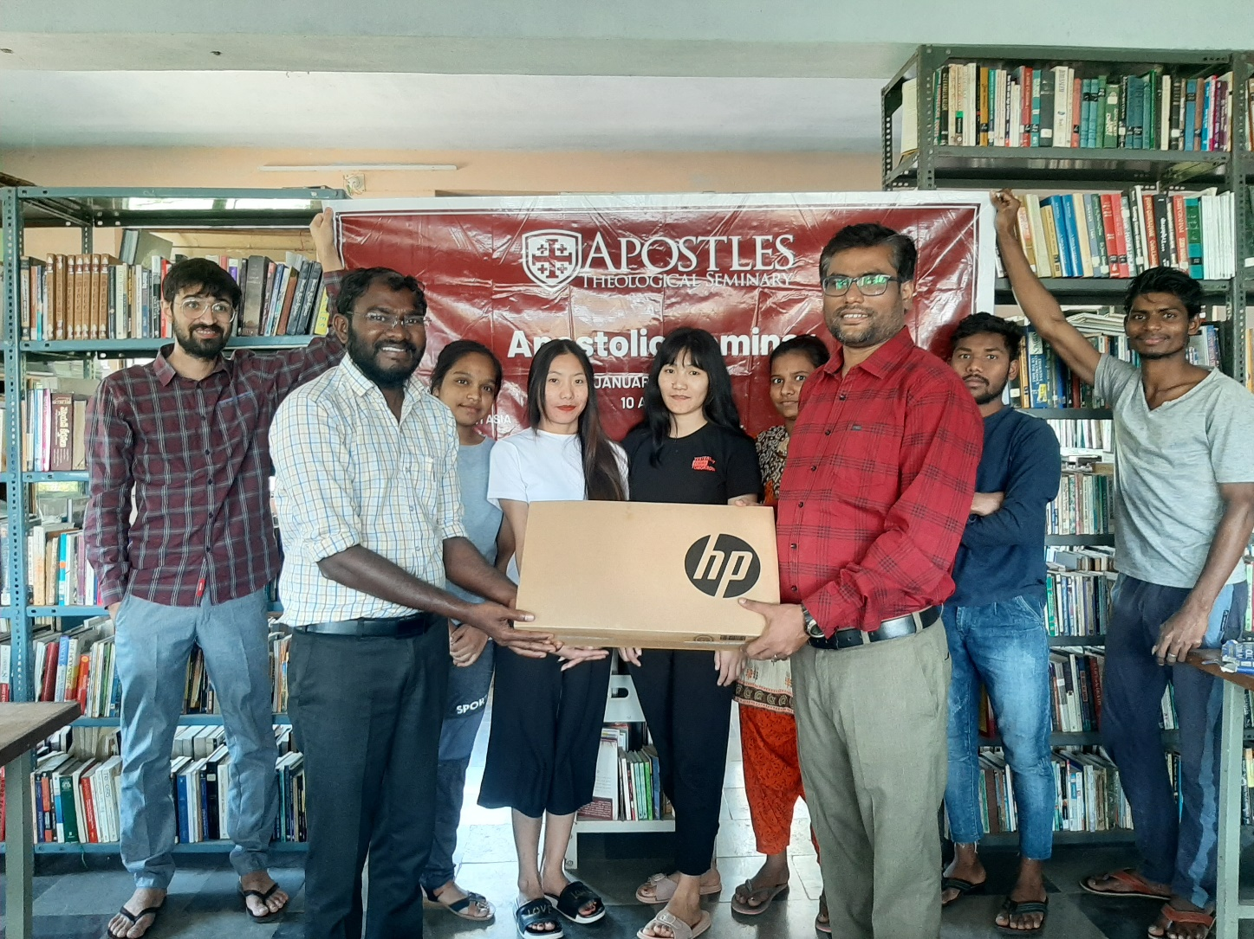
Donated Laptop to the Seminary Director Dr. Joshua.
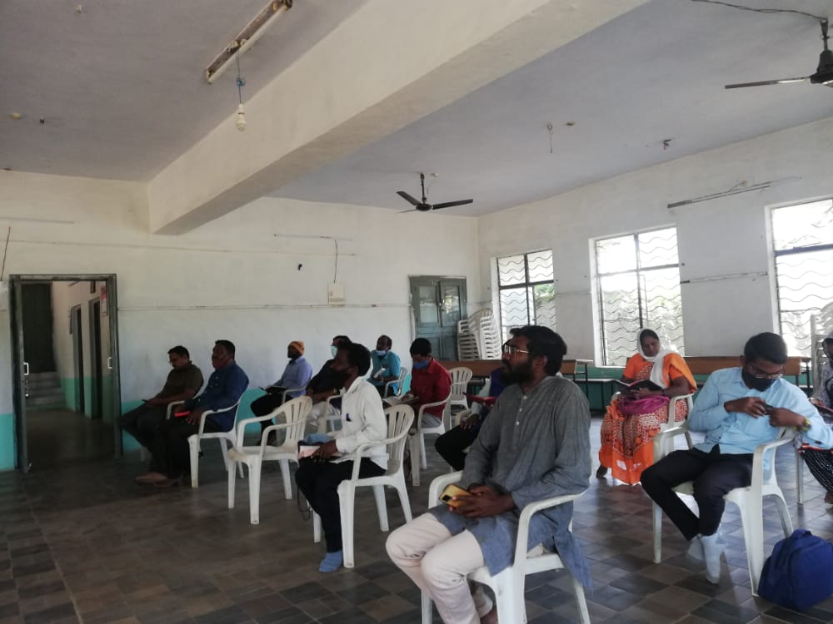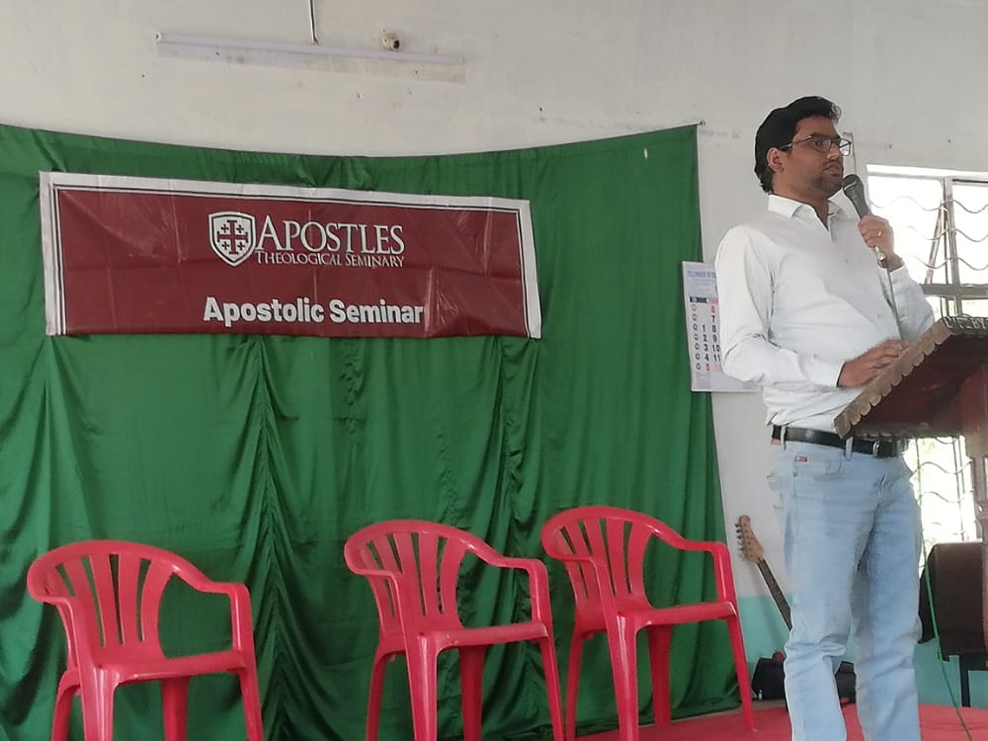
Apostolic Seminar to the Pastor’s Families affected and died due to Covid.
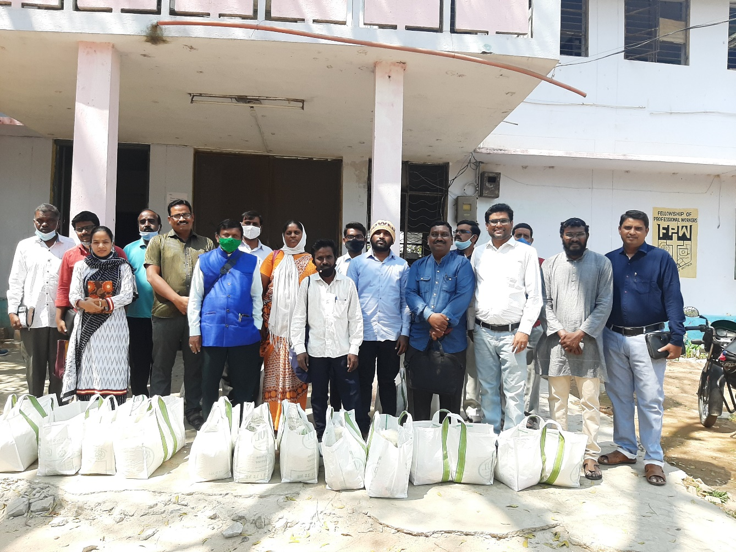
Distribution of groceries for the needy Pastors.
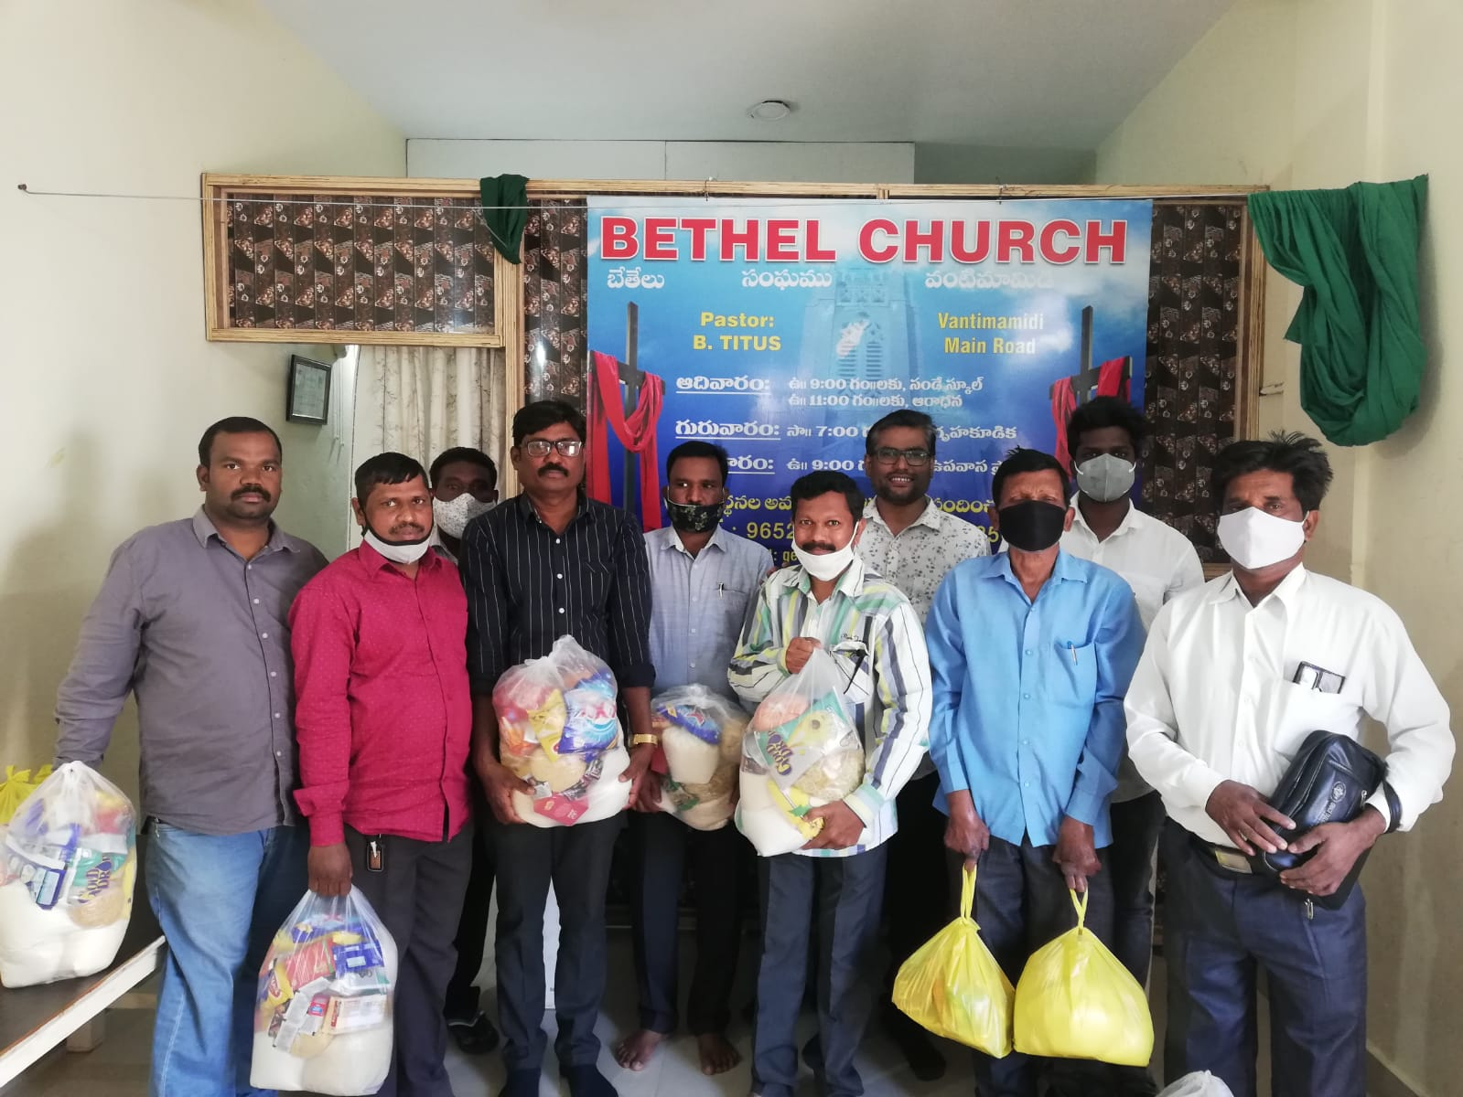
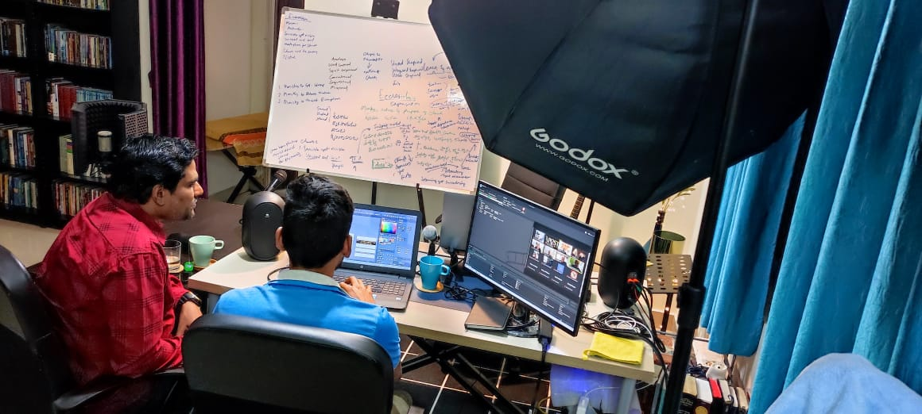
Working with the media team for the Summit Videos.
The Kingdom Community of God or the Redeemed Community of God expanding through the Vision and mission of the CAC presiding Apostle and all the members inspite of Pandemic and Persecutions.
Teaching, equipping in the authentic apostolic and Prophetic revelations which are available online.
Pray for:
- CAC India and South Asia members.
- ATS centres.
- CAC Apostolic Seminars.
- Translation Work in Major languages.
- Digital Marketing Of GKI, CAC and ATS materials.
- In India Persecution against Christians, Christian Institutions are high, Anti - Christian Government laws (government is not giving permissions to the church building constructions, Christian institutions, cancelled all the foreign funding to the charity organizations, for baptism we need to get police and district magistrate permission is mandatory).
Upcoming Trips In March 2022
Bangalore & Delhi

For Christ’s Sake,
Ravi Paul

