International Leadership Seminar At Siliguri, West Bengal, India.
Dearly beloved Apostles, friends and co-workers,
As we usher in the new year, I join in greeting you, and all that are in your circles, a very joyful year, filled with the “peace that passeth all understanding”. May we all bask in the confidence that we are all in His Almighty hands of love and grace. This confidence will also fill us with the strong faith that under any circumstance “ all things work together for good”.
I thank you with all my heart, for being such wonderful helpers within the scope possible to each of you. The possibility of collaborating with you in this high commission was a gift given by God, and I am humbled by it.
A special word of thanks to our Presiding Apostle George Kouri who dedicacted his life, time, energy and money for the reformation of the Lord’s Church. Our great God did not dissappoint us, but yet again reveled Himself with blessed experiences to all who laboured towards comprehending Him.
Our task is not complete until we are with Him and see Him face to face. Until then, I wish that we will all be “Faithful to Christ”, as we travel together, until we reach the goal that He, in His greatness, has set for us.
Highlights of Our Trip To Siliguri
One of the strategy of CAC India Campaign is organizing Leadership Seminars across the key cities and towns of India. For the year end of 2017, we have organized International Leadership Seminar at Siliguri,Darjeeling which is the gateway for Himalayan region with neighbouring countries like Nepal, Burma, Bhutan, China, Tibet and Bangladesh.

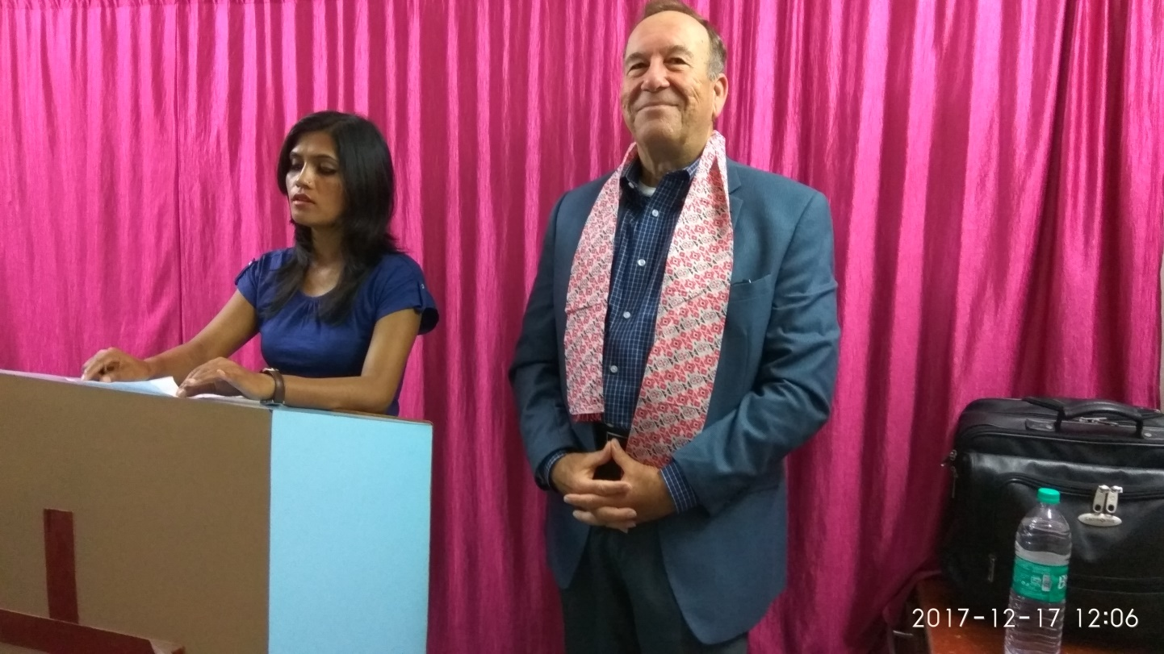
On Sunday morning service was at Kings Church, Siliguri.
On Sunday, December 17 Mike preached in Siliguri to the saints who are members of churches founded by Apostle Adam Rangnamei. Mike brought the prophetic word for the church, encouraged them to be bold and courageous as the future will be bright through Jesus. Realease of the prophetic utterances charged the faith of the believers.
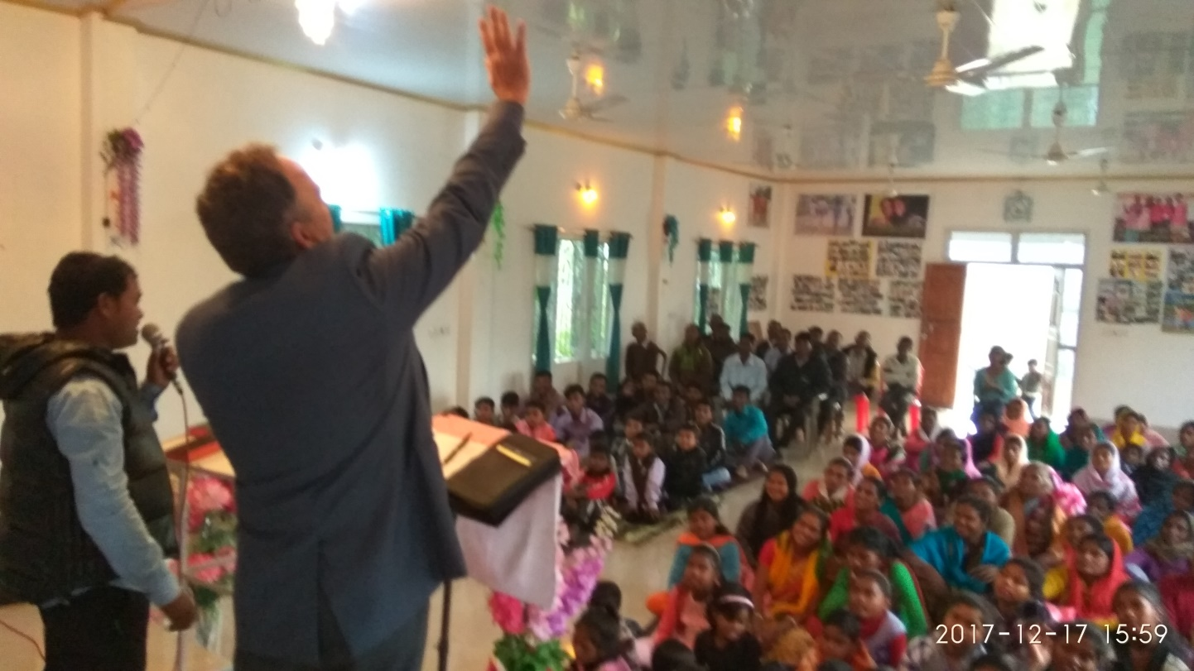
Apostle Mike Preaching at Kamalbagh Tea Gardens on 17 December, 2017.
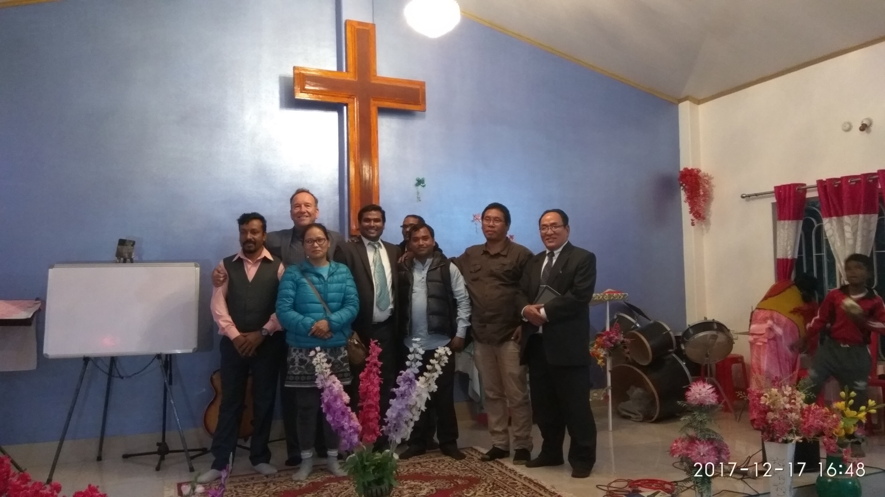
International Leadership Training Seminar
December 18 and 19,2017 International Leadership Training Seminar in Siiguri-Darjeeling region was hosted by Nima Rangnamei, Adam’s widow, and Pastor Kaping.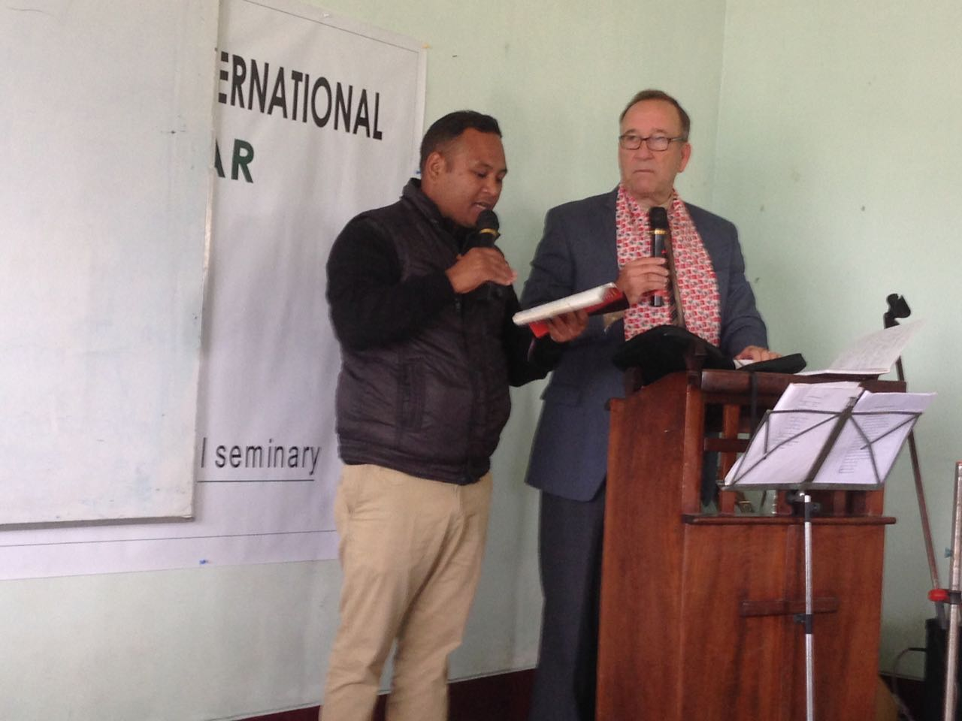
On Monday and Tuesday the 18 and 19, they ministered in a Leadership Training Seminar and Workshop encouraging and strengthening the leaders and ministers who are partnering with us in Northeast India, Nepal, Bangladesh, Bhutan, Burma, Tibet and Myanmar. Around 55 apostolic and pastoral leaders from Siliguri, Darjeeling, and these Southeast Asian nations attended the two-day leadership-training seminar led by Apostle Daub.
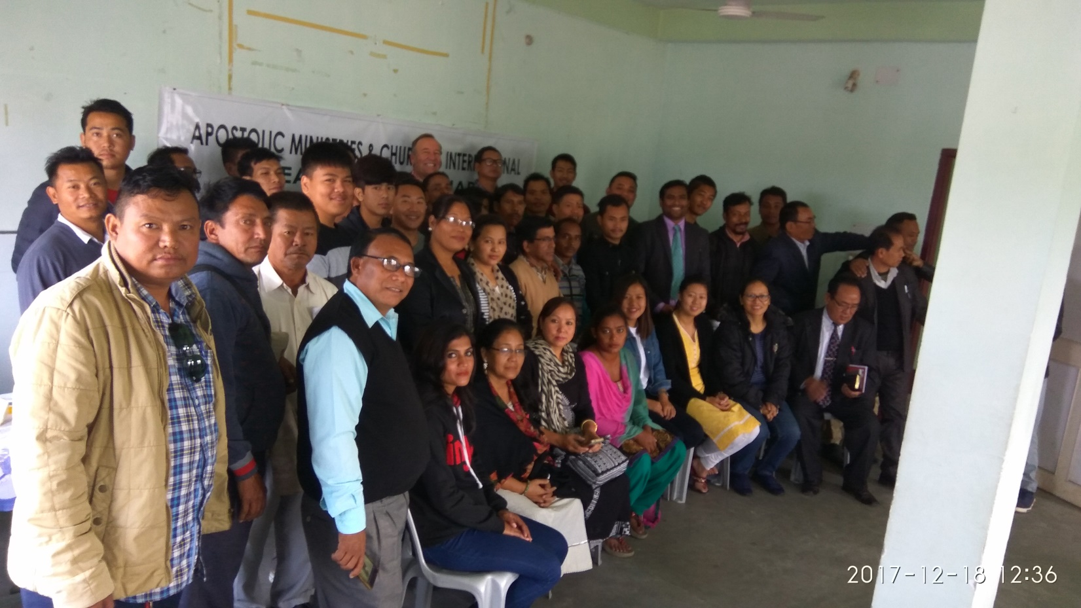

Special Sermon By Apostle Michael Daub
Day 1
- Language of God – Session 1
- Goodnews of the Kingdom of God - Session 2
- Apostle in the 21st Century – Session 3

Day 2

- Hope of Glory – Session 1
Had a brief meeting with the faculty of the Apostles Theological extension seminary founded by Apostle Adam. 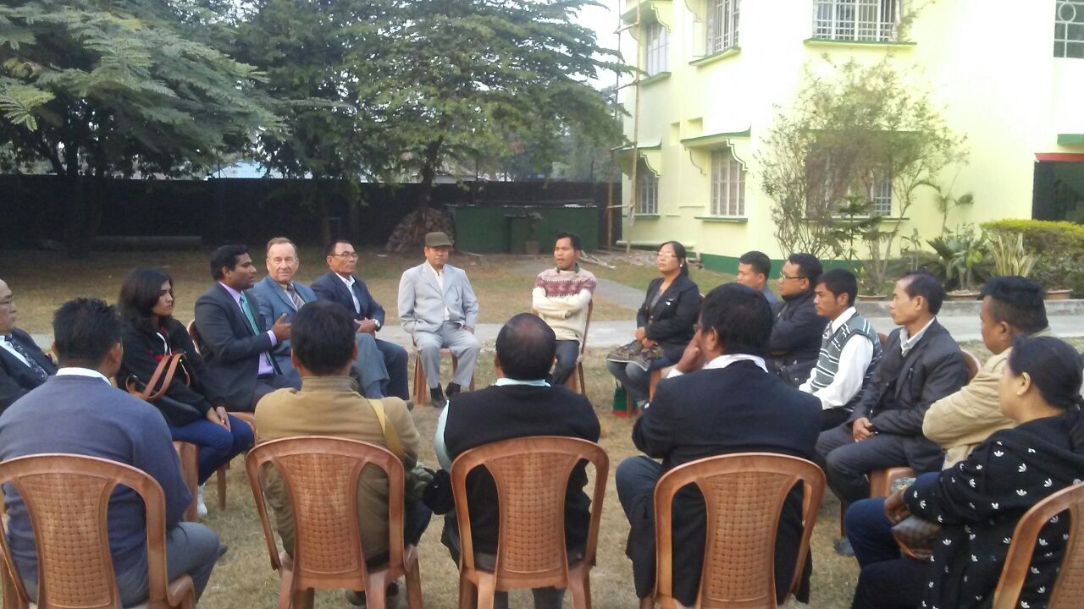
Faculty Members are volunteering themselves to continue the work left by Late Apostle Adam.
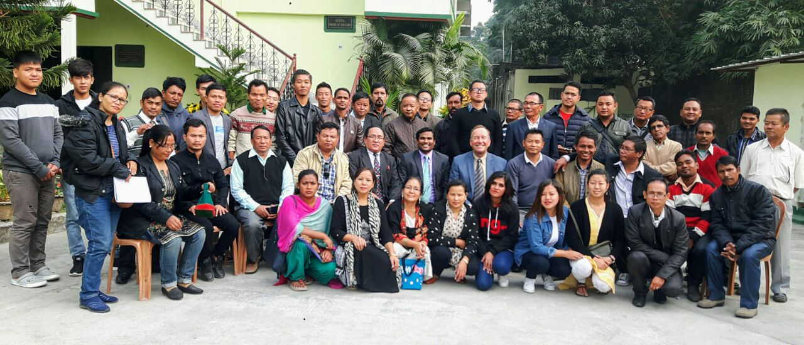
Around 55 apostolic and pastoral leaders from Northeast India, Nepal, Bangladesh, Bhutan, Burma, Tibet Myanmar and from Siliguri, Darjeeling .
Summary
India December 2017:
Summary with George Kouri and Ravi Paul Wed. December 20 @ Banjara Hills Residence
- Apostle Michael Daub
_____________________________________________________________________________
- What is Needed at This Time:
- Work with Ravi to build a strategy for many regions
- Focus on changing the thinking of the new leaders
    - Biblical Theology
    - Kingdom is in Word and Spirit
    - Government and Councils
    - Holy Nation
- The many streams are still not coming together
    - Historic
    - Reformed
    - Evangelical
- The Revelation of the Kingdom of God in Christ
    - Proper Hermeneutic
    - The Architecture of the Kingdom
- ATS directed study courses by GEK
i. Course # 1: Kingdom Theology
  - Biblical Theology c/o Chilton Paradise Restored
  - Dominion Theology of Jesus and the apostles.
ii. Course # 2: The Book of Revelation
  - The Revelation of Jesus the Christ
  - Prophet, Priest and King
  - His Church, the Bride of Christ

iii. Course # 3: The life & Ministry of Jesus Christ
  - 3 ½ years with Jesus
  - Ruler and King of the Earth
  - F.W Farrar
  - Alfred Eidershiem
  - A.T. Robertson; Harmony of the Gospels
- The Apostolic Teachers
    - Quarterly sessions
    - Disseminate the Kingdom Message
    - MLD one of 12
    - Jim Hodges
    - George Runyan
    - Etc.
- Ravi as National Director
- Ravi is preparing to lead the CAC India Campaign.
- Ravi will provide a report to CAC
  - With review c/o MLD
  - Include notes and recommendations from today
- The N.E Himalayan Region
- Ravi has contacts in Darjeeling for:
- Leadership Training.
ii. To bring a “pure word” to the region
        - versus speculative theology that divides the community.
- Have Kaping and Nima attend the Apostolic Summit in Hyderabad, February 2018.
- Create a Calendar for 2018
- Follow Up with Darjeeling ATS leadership
- Nepali Speaking Pastor for King’s Church
- Ravi’s Summary of 4 days in Siliguri
- Consideration for Adam’s Brother as replacement
- Replace the donor mentality of the Baptist Mission with Kingdom Economics.
- Do an Apostolic Summit in Siliguri as a follow up.
- budget 37,000 Rupee
- address the need of the NE India states

