CAC India Apostolic Campaign January 2022 Report

“Peace be to the brethren, and love with faith, from God the Father and the Lord Jesus Christ. Grace be with all those who love our Lord Jesus Christ with incorruptible love”.
Dear Presiding Apostle and Executive Council members of CAC,
Greetings in the victorious name of our King Lord Jesus. It was a great beginning for CAC India and South East Asia apostolic campaign to start the new year 2022 with powerful authentic apostolic and prophetic teachings through online and offline in various parts of India, Nepal and Bangladesh in spite of Covid and Omicron restrictions.
Apostolic seminar in the Seminary
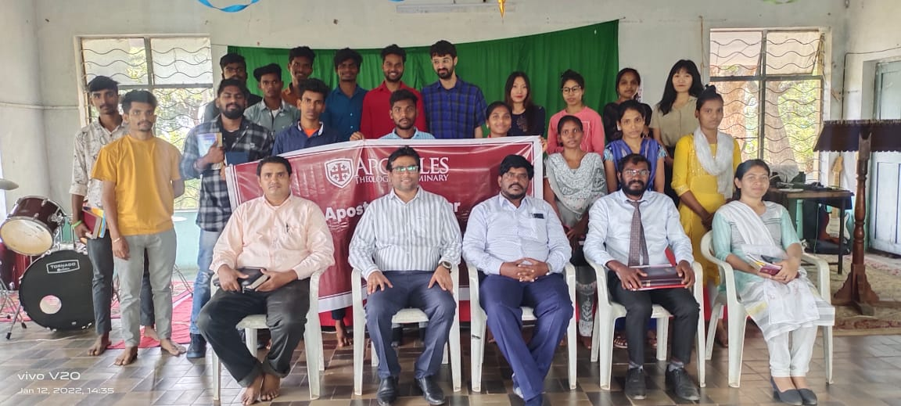

Started ATS Crash Course at South Asia Theological College, Hyderabad for students who are in the final year of their Masters residential program.

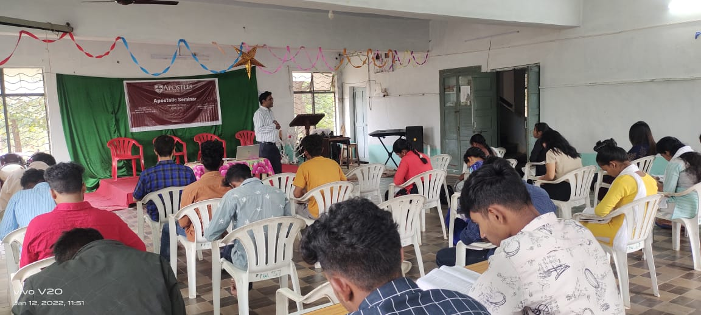
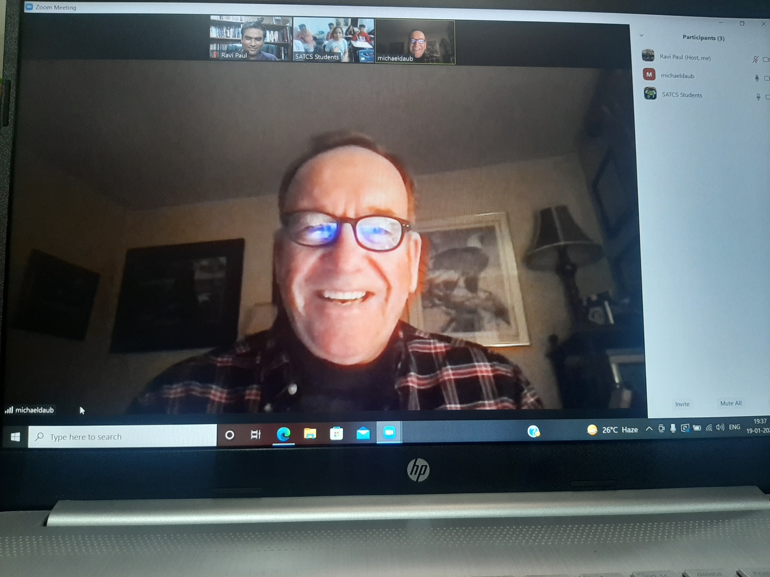

Apostle Mike daub taking online session for the seminary students.

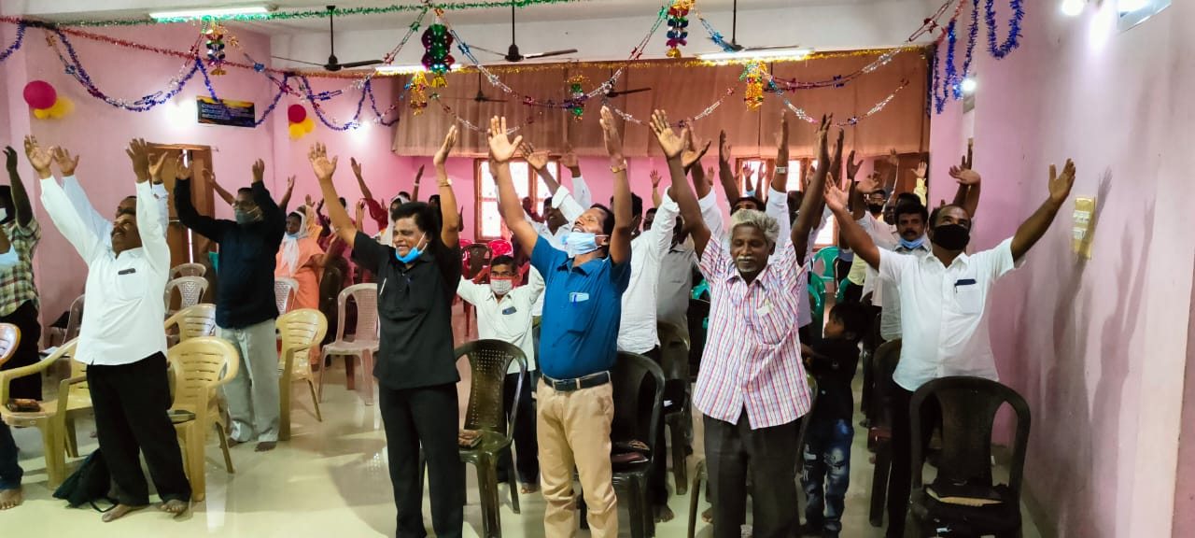
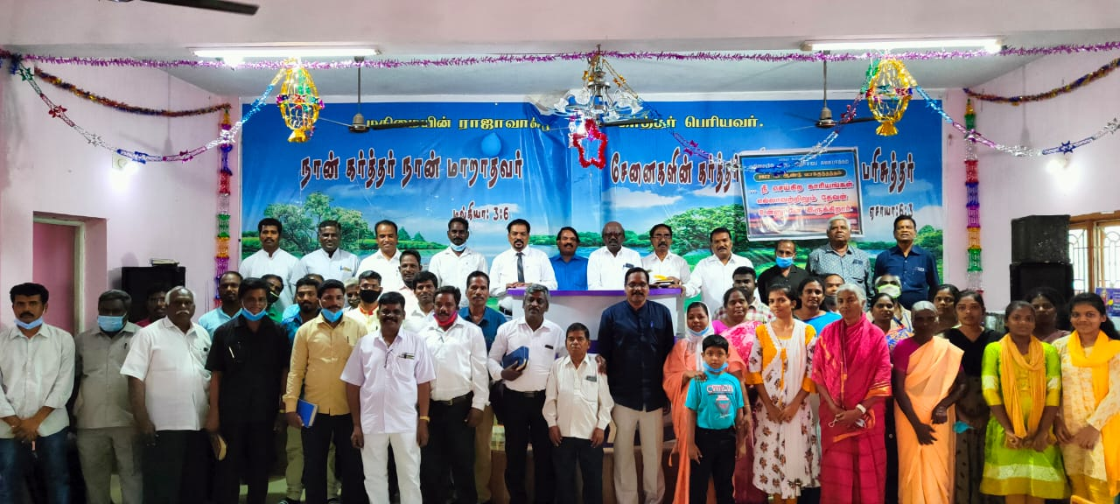
Bishop Samuel from Chennai encouraging the Pastors and families through the ATS curriculum

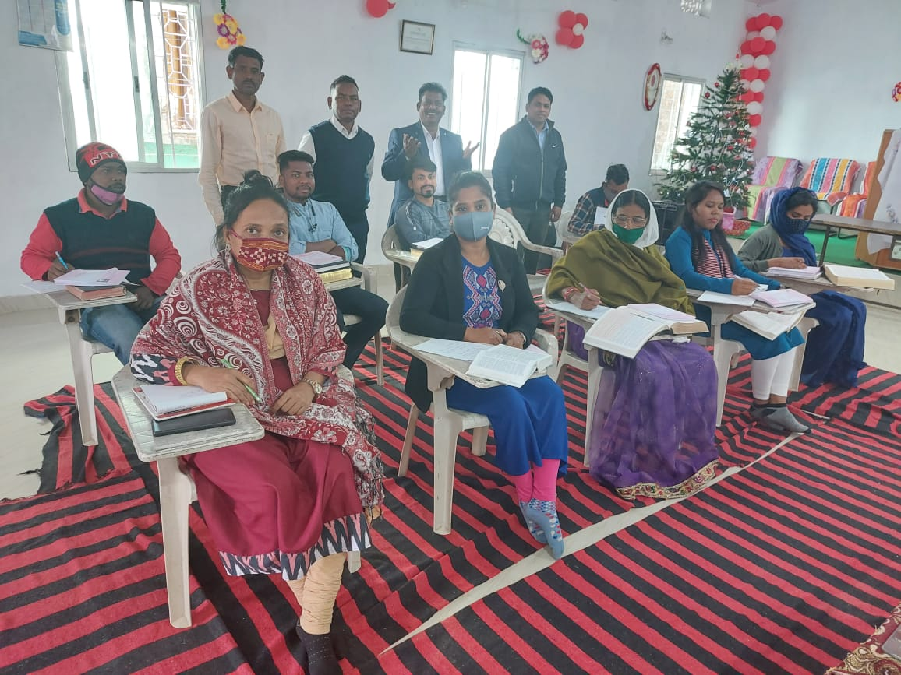
Satellite centre at Orissa run by Dr.Surya.
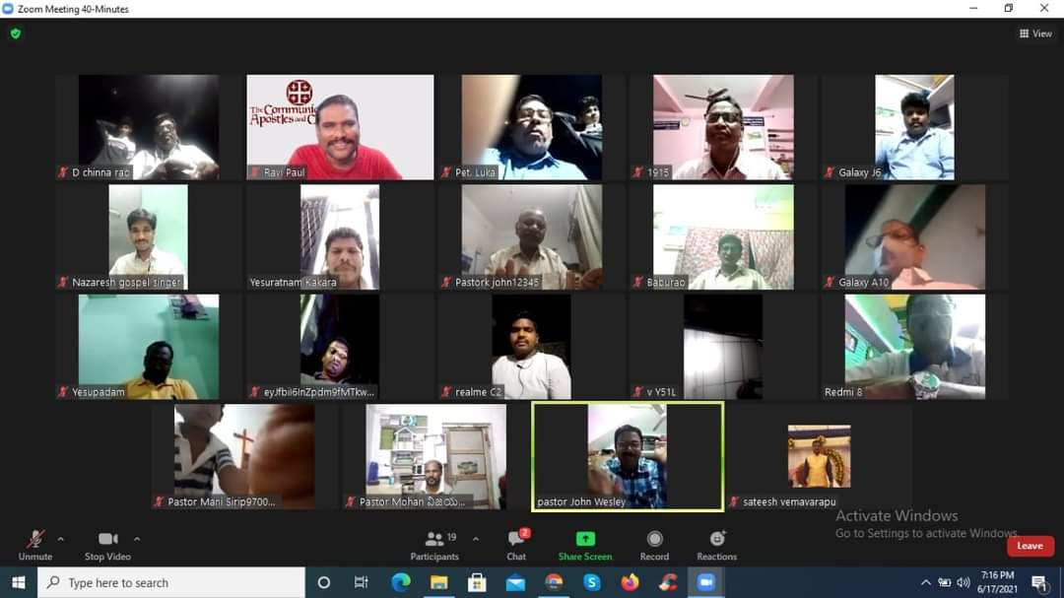
Online sessions for the Pastors in the City of Vizag.
Preaching the Gospel of the Kingdom in a Pentecostal church, Who do not believe in the Kingdom and postpone the Kingdom.
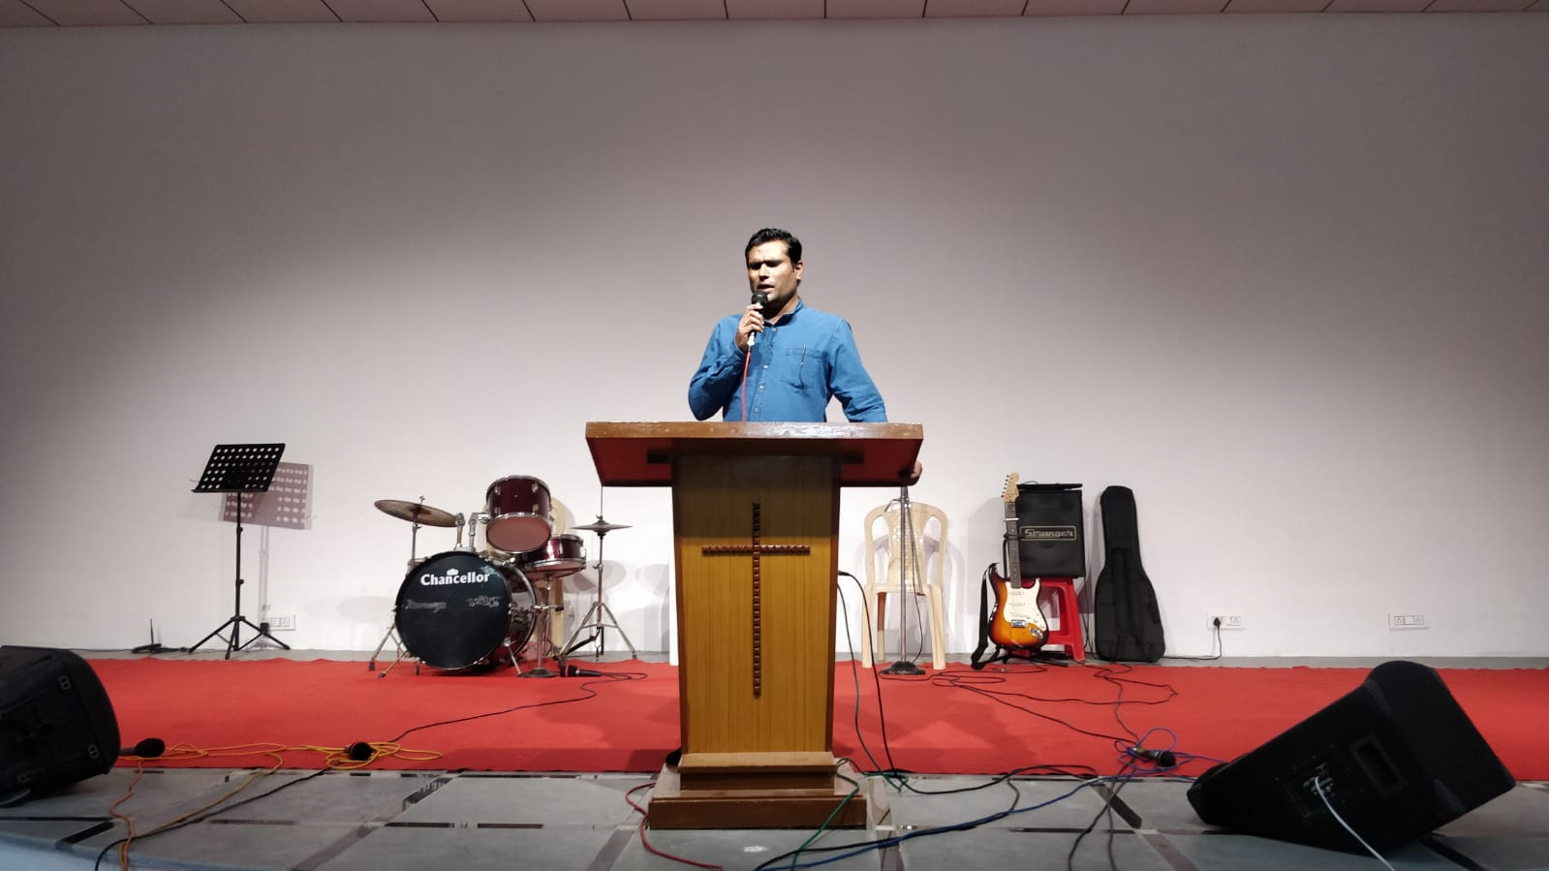

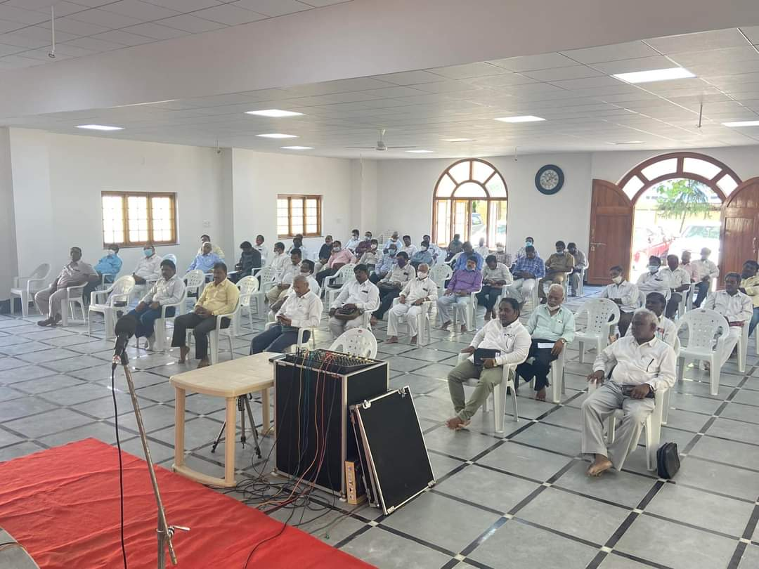
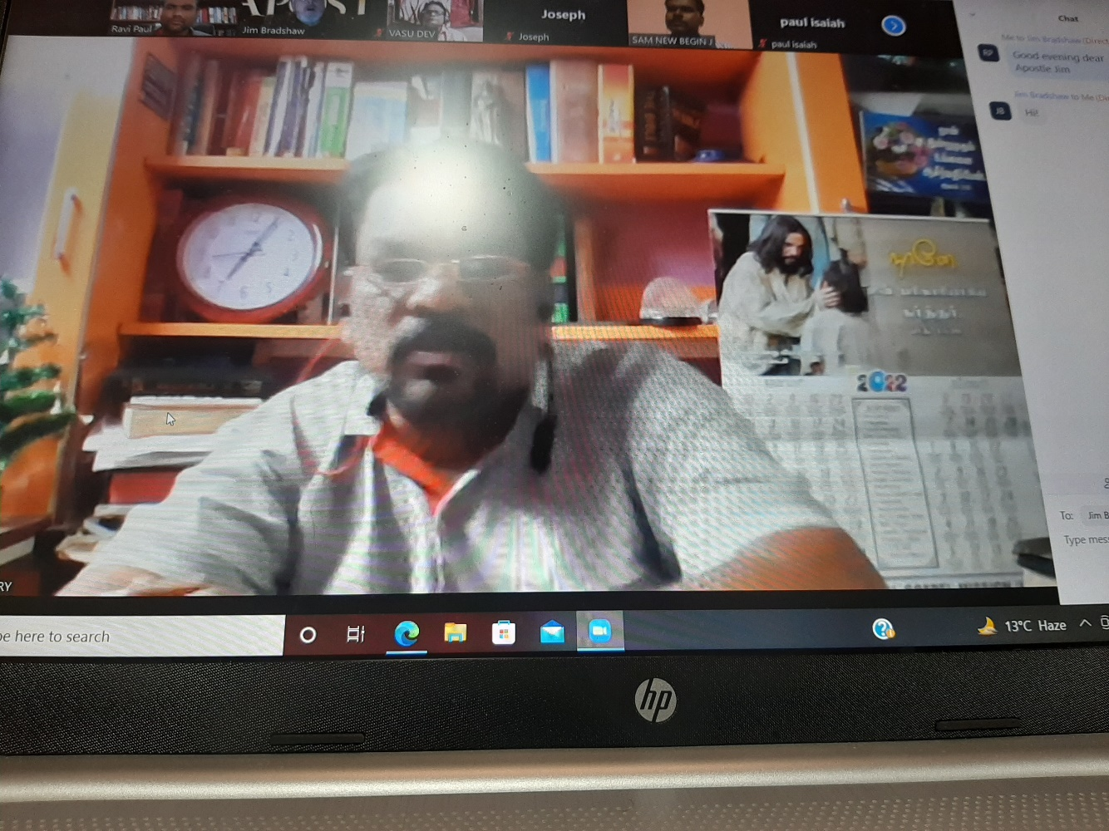
Doctoral program orientation by Apostle Jim Bradshaw with 11 Students from Chennai, administrated by Dr.Samuel.

Social Activities:
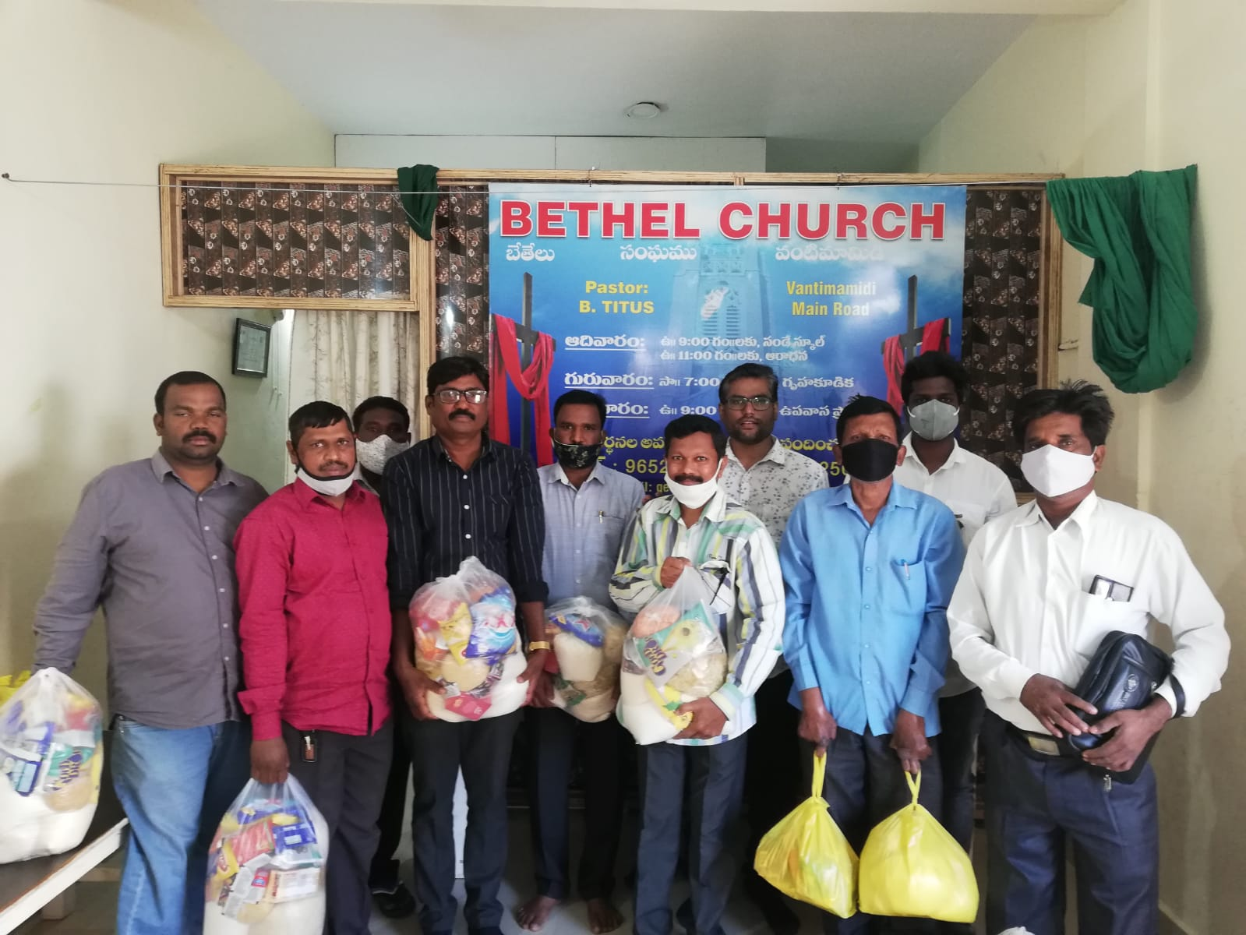
Essential provisions distribution to servants of God affected with severely due to Covid and lockdown.
Severe persecution from hindu fanatics, as few Pastors and Christian believers died due to covid the rumours are high that all those who convert to Christianity will die. To strengthen the Pastors we have organized a apostolic seminar and distributed the groceries which will help them for a week. And many more charity works are done through our associate ministries like daily feeding poor children in various slums of India.

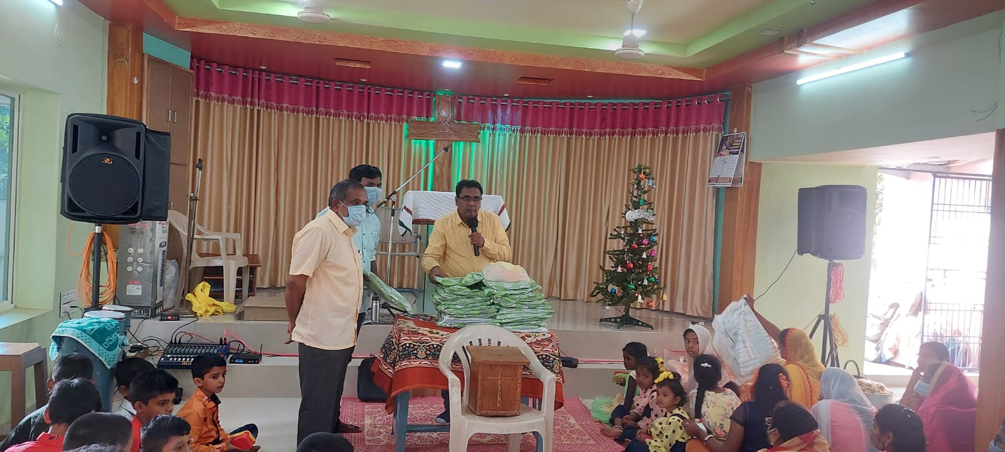

Clothes distribution to Poor families, widows.

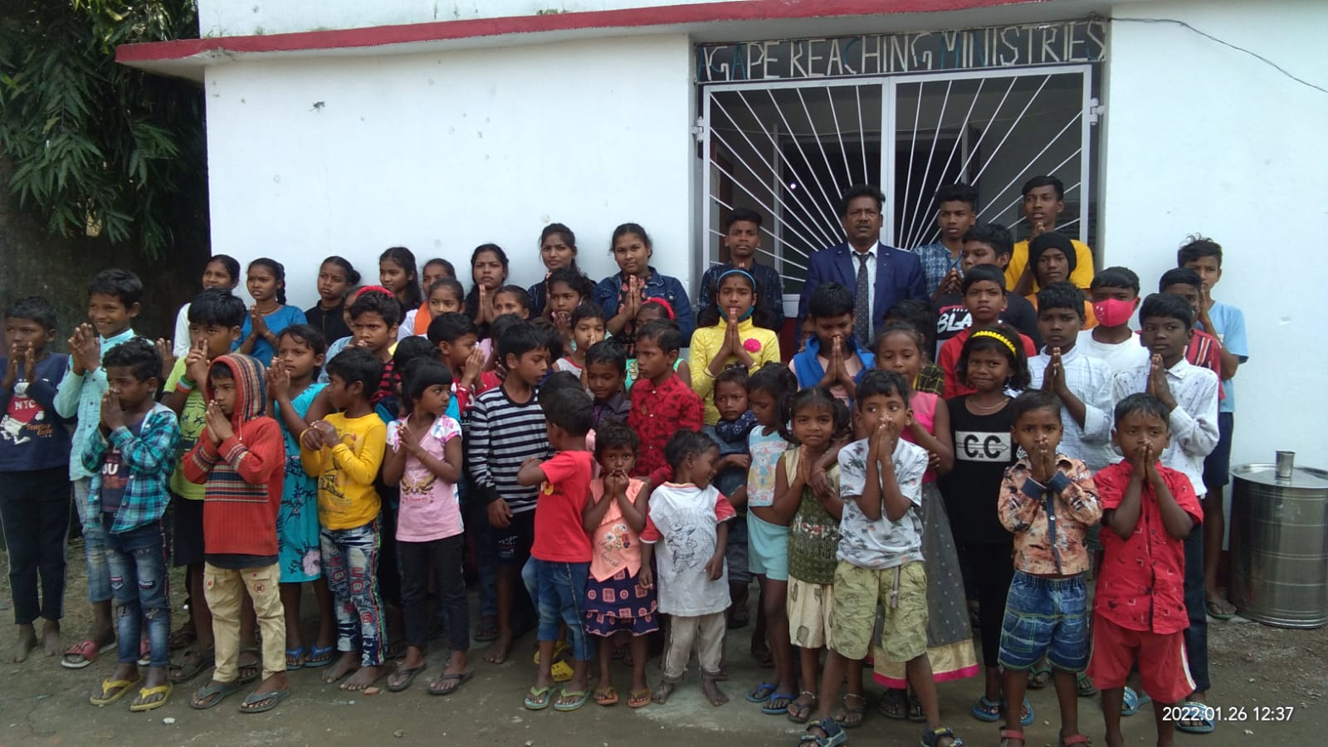
Poor children feeding program at Orissa.

Praying for new church building projects
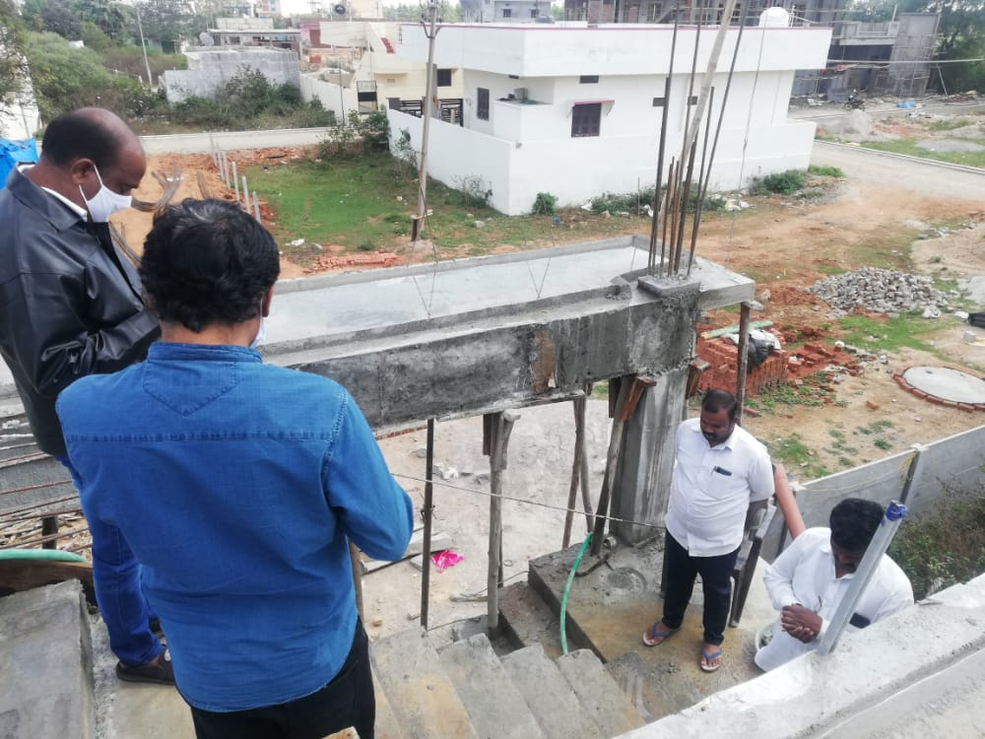

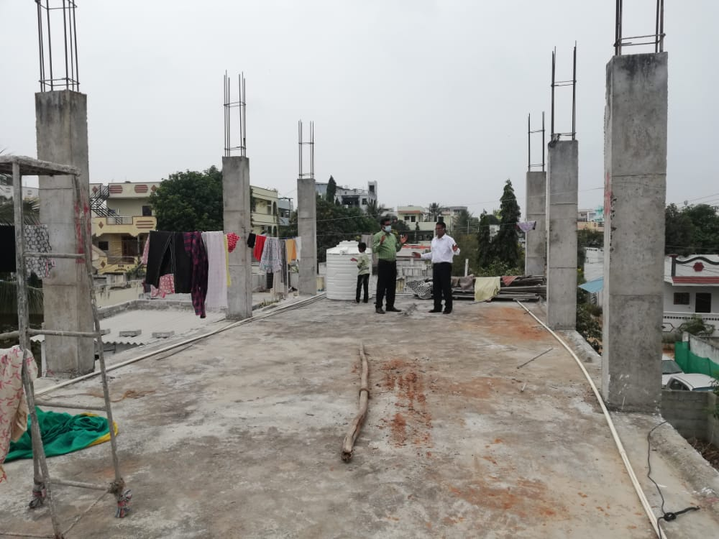

ATS Centres Still In startup stage the key cities :
Vizag,
Banglore,
Punjab,
CAC India and all the team members are striving hard to preach and teach the authentic apostolic and prophetic teachings through extensive use of the available online resources.

We thank Apostle George Kouri and Apostle Mike daub and all the council members for your continuous apostolic powerful prayers and blessings. As we implement the CAC strategies across the South Asia.

Regrads,
Ravi Paul & Team.

